**Assignment - 3**

**Python Programming**

|  |  |
| --- | --- |
| Assignment Date | 06 October 2022 |
| Student Name | Daphne Sharon R |
| Student Roll Number | 311119205009 |
| Maximum Marks | 2 Marks |

**Description:** Predicting the age of abalone from physical measurements. The age of abalone is determined by cutting the shell through the cone, staining it, and counting the number of rings through a microscope -- a boring and time-consuming task. Other measurements, which are easier to obtain, are used to predict age. Further information, such as weather patterns and location (hence food availability) may be required to solve the problem.

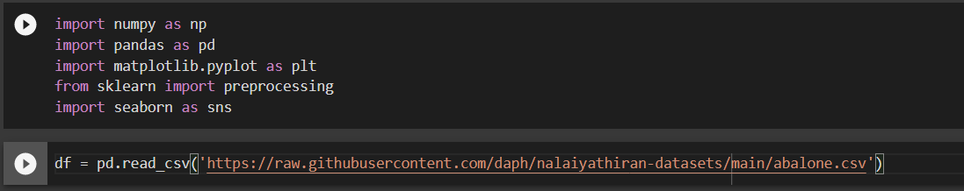

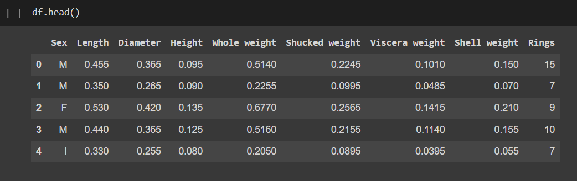

**UNIVARIATE ANALYSIS**

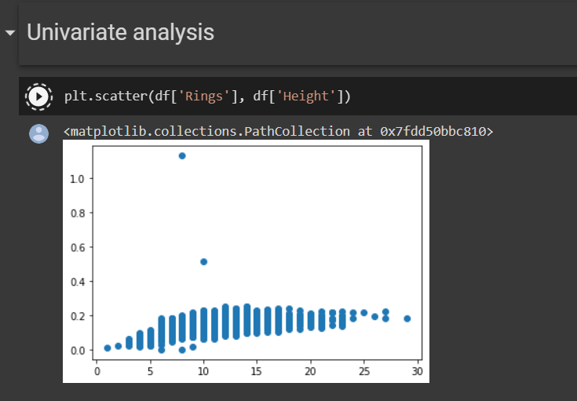

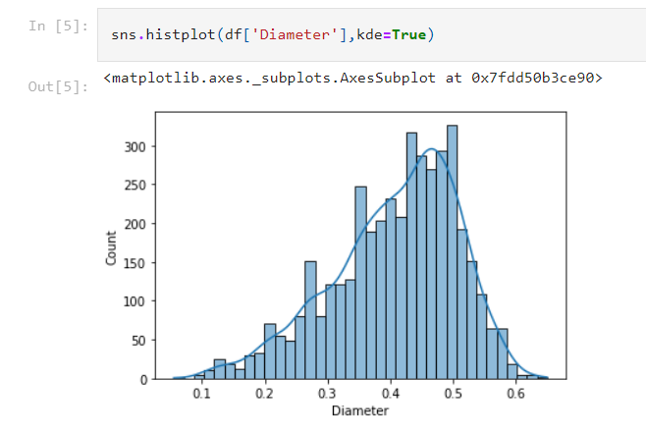

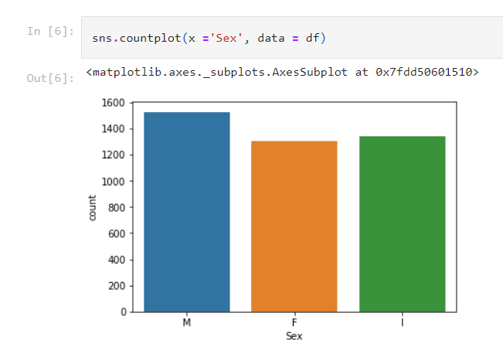

**BIVARIATE ANALYSIS**

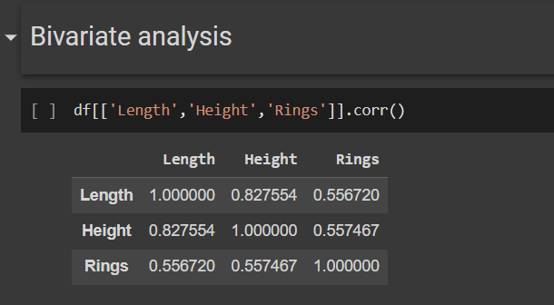

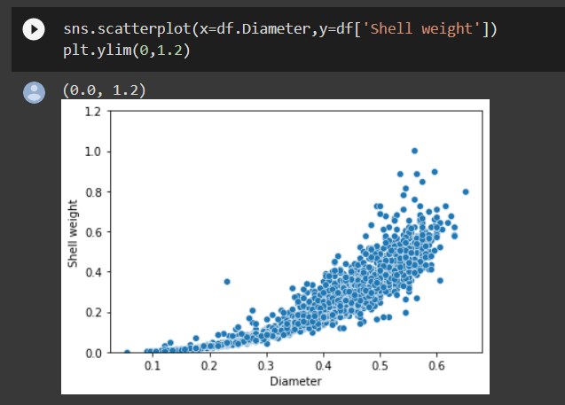

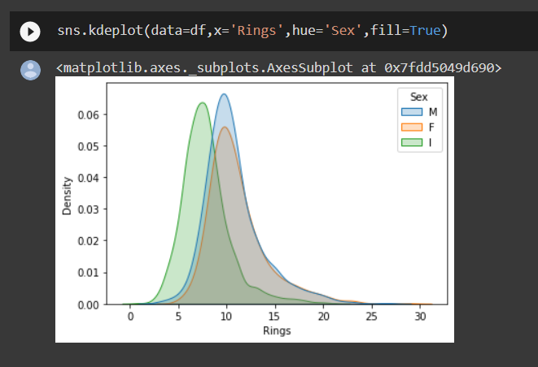

**MULTIVARIATE ANALYSIS**

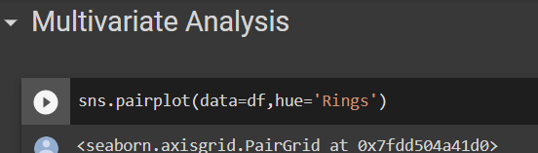

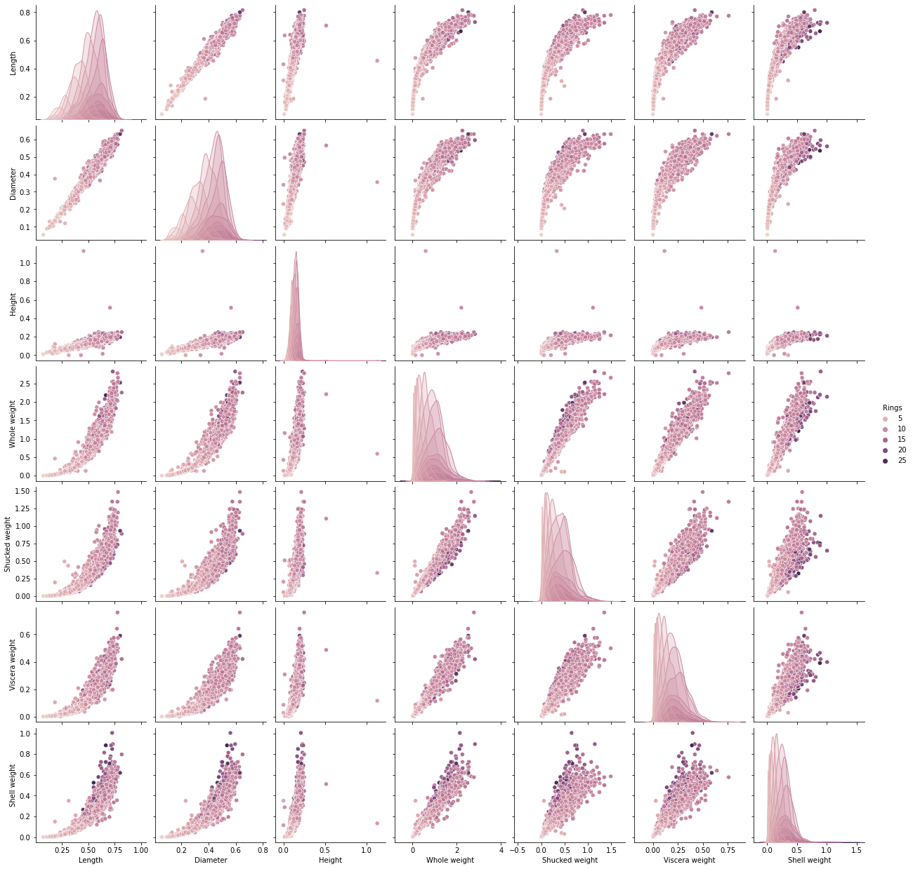

**PERFORM DESCRIPTIVE STATISTICS ON DATASET**

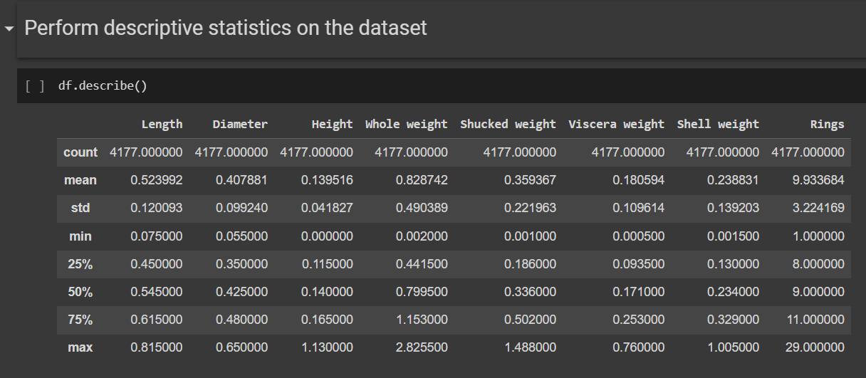

**CHECK FOR MISSING VALUES**

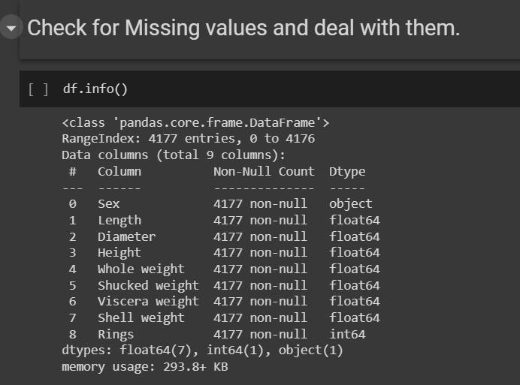

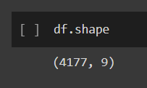

**FIND OUTLIERS AND REPLACE THE OUTLIERS**

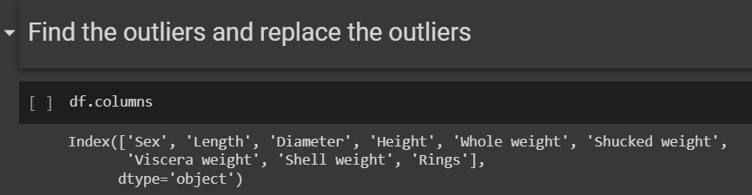

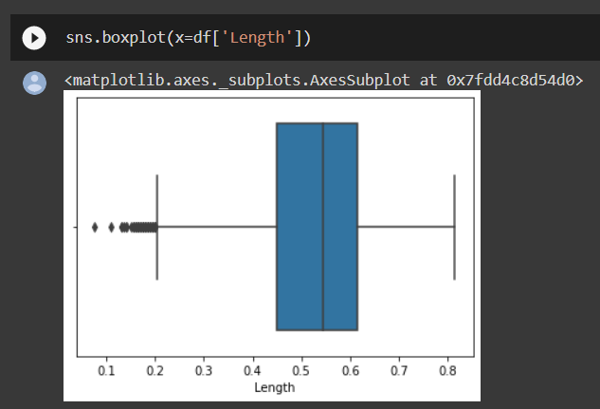

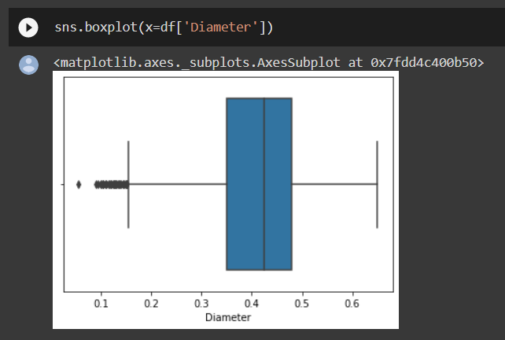

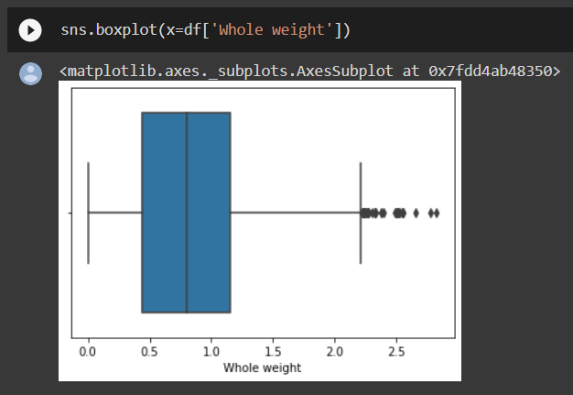

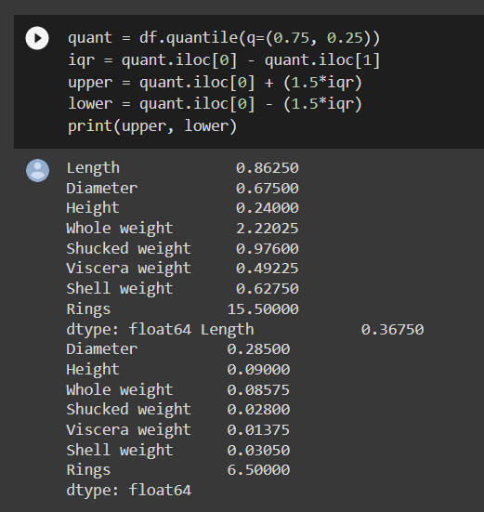

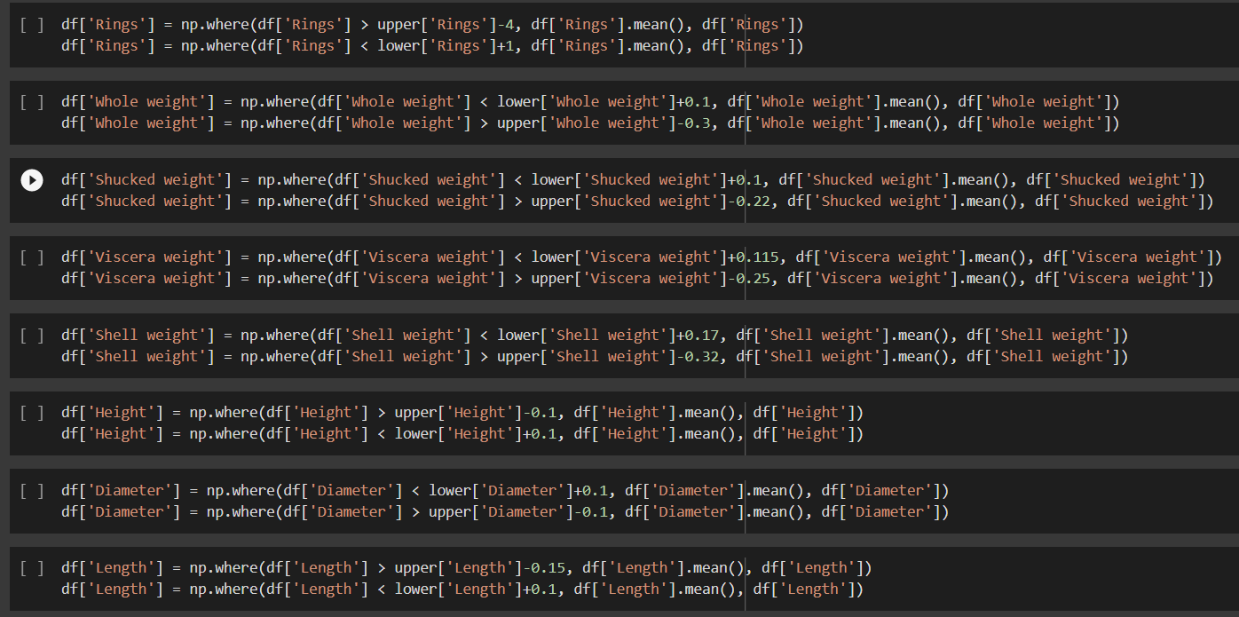

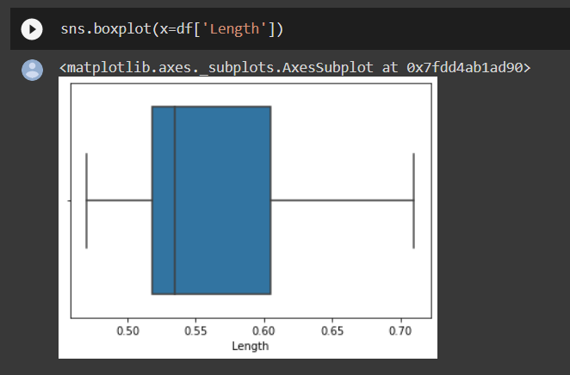

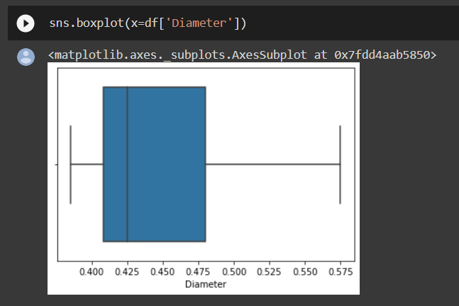

**CHECK FOR CATEGORIAL COLUMNS AND PERFORM ENCODING**

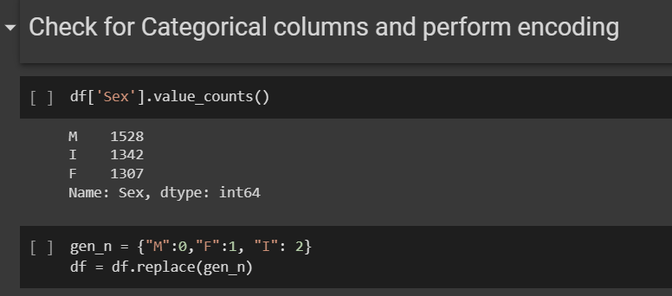

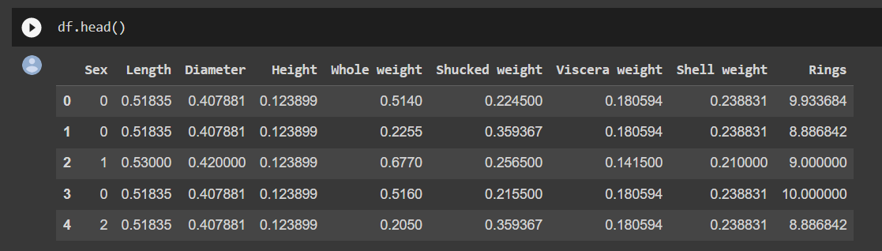

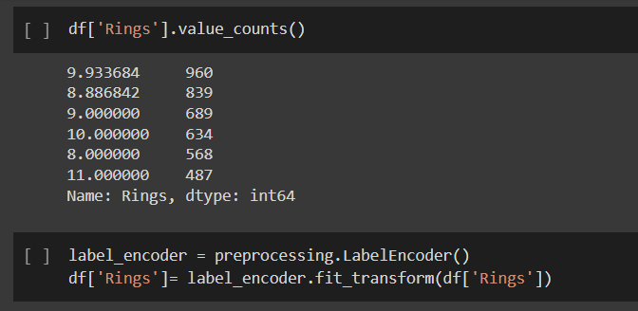

**SPLIT THE DATA INTO DEPENDANT AND INDEPENDENT VARIABLES**

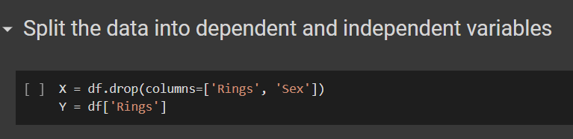

**SCALE THE INDEPENDENT VARIABLES**

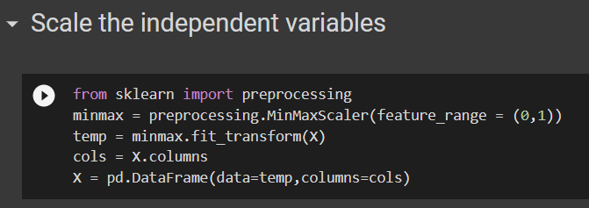

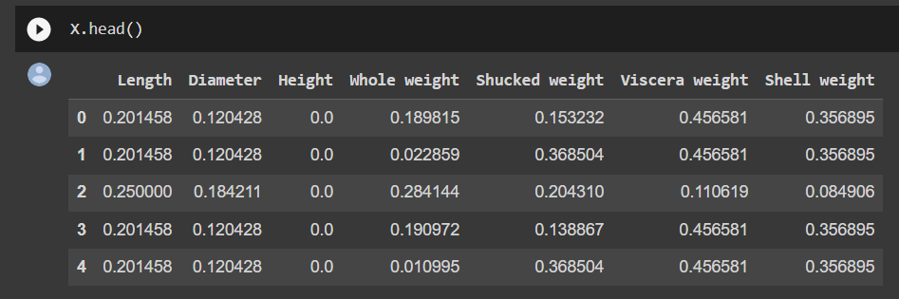

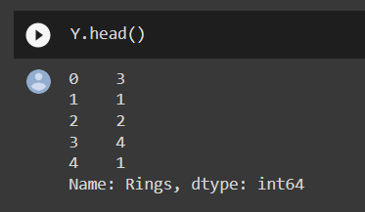

**SPLIT THE DATA INTO TRAINING AND TESTING**

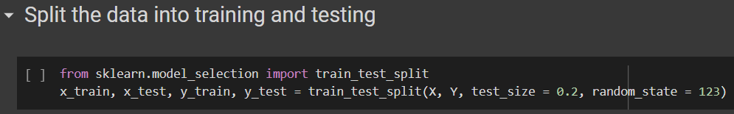

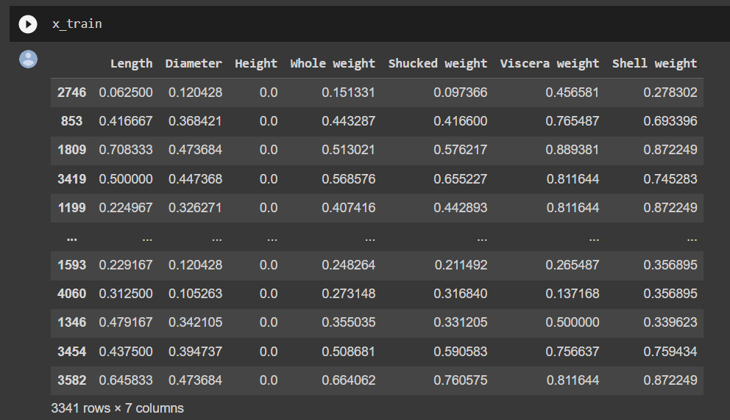

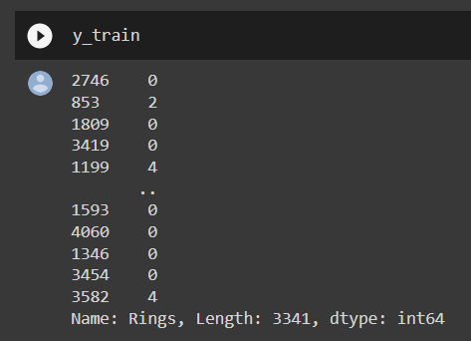

**BUILD THE MODEL**

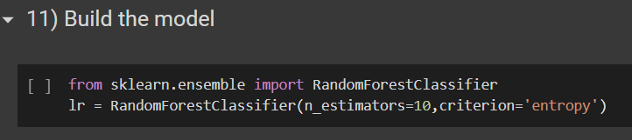

**TRAIN THE MODEL**

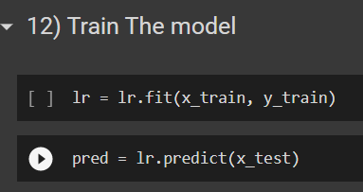

**TEST THE MODEL**

